Windows Event Viewer Log Analysis

- Logon & Logoff Activities
Analyze:
- Event ID 4624 – Successful Logon
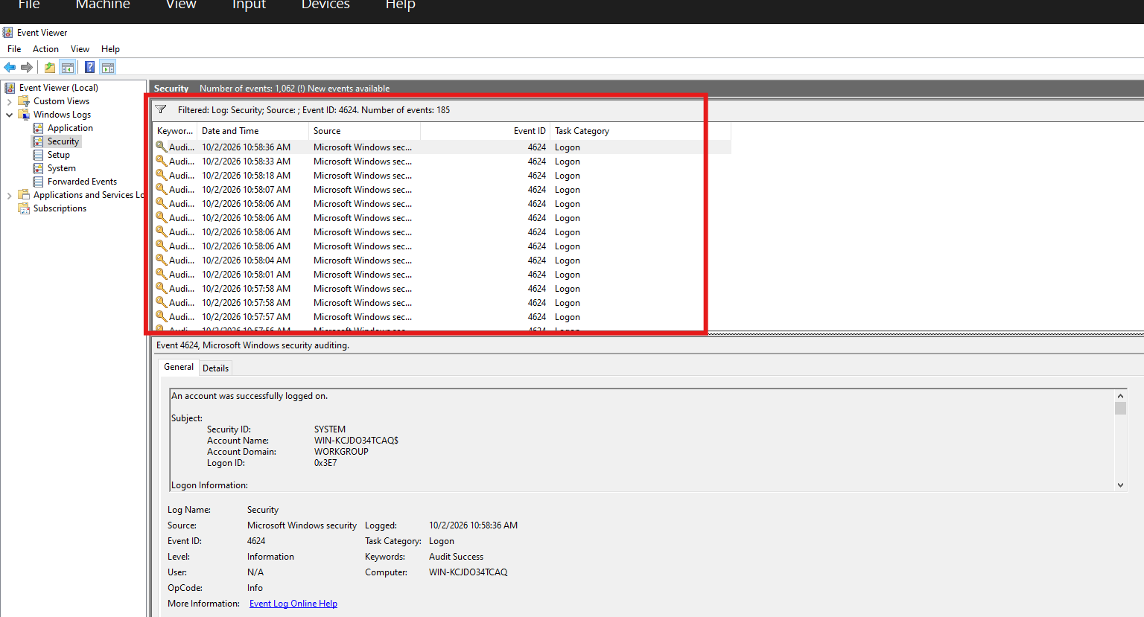
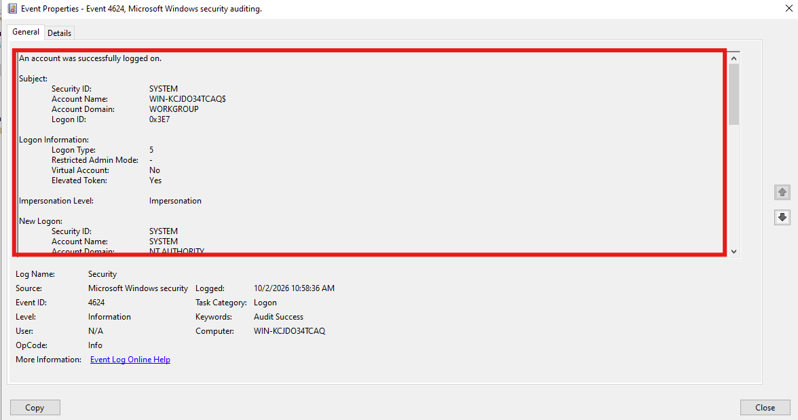

- Event ID 4634 – Logoff / Session End
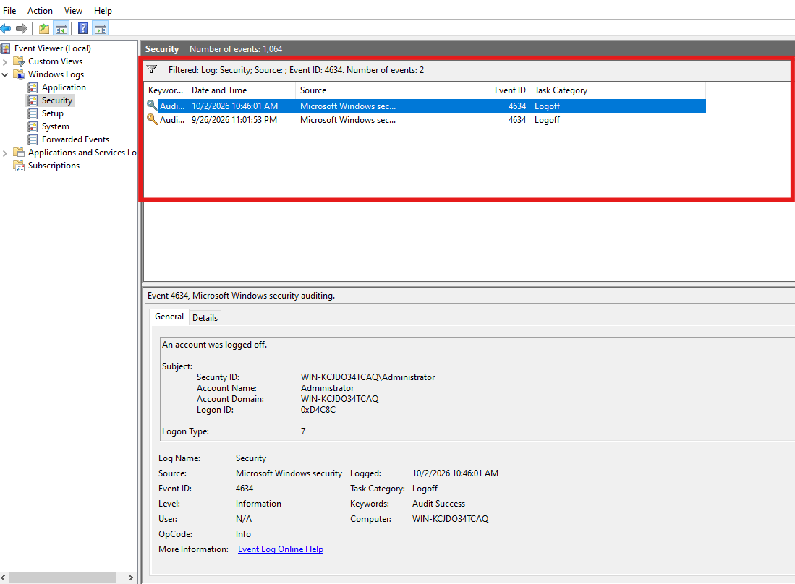
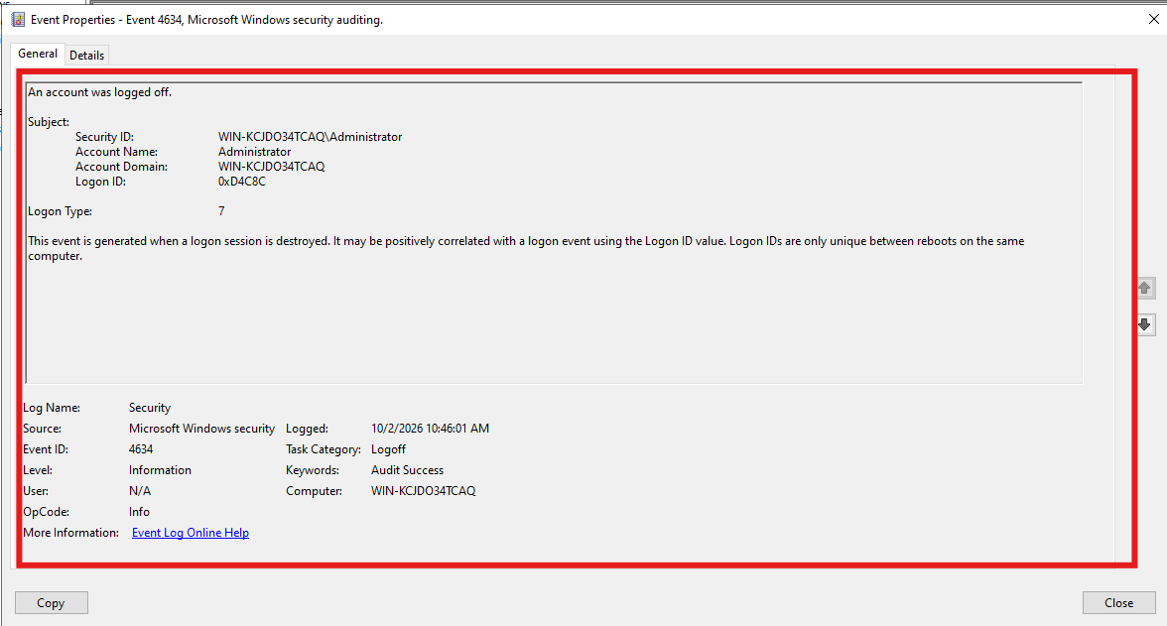

- Failed Login Investigation
Analyze:

Event ID 4625 – Failed Logon

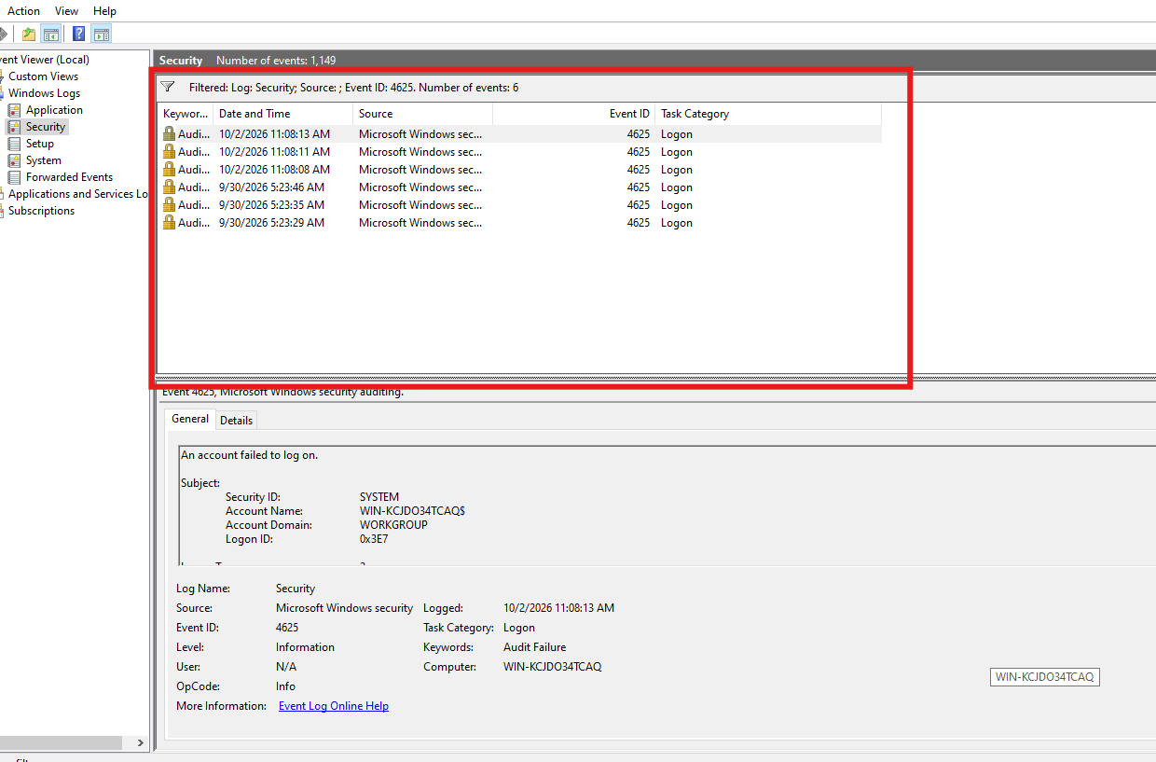
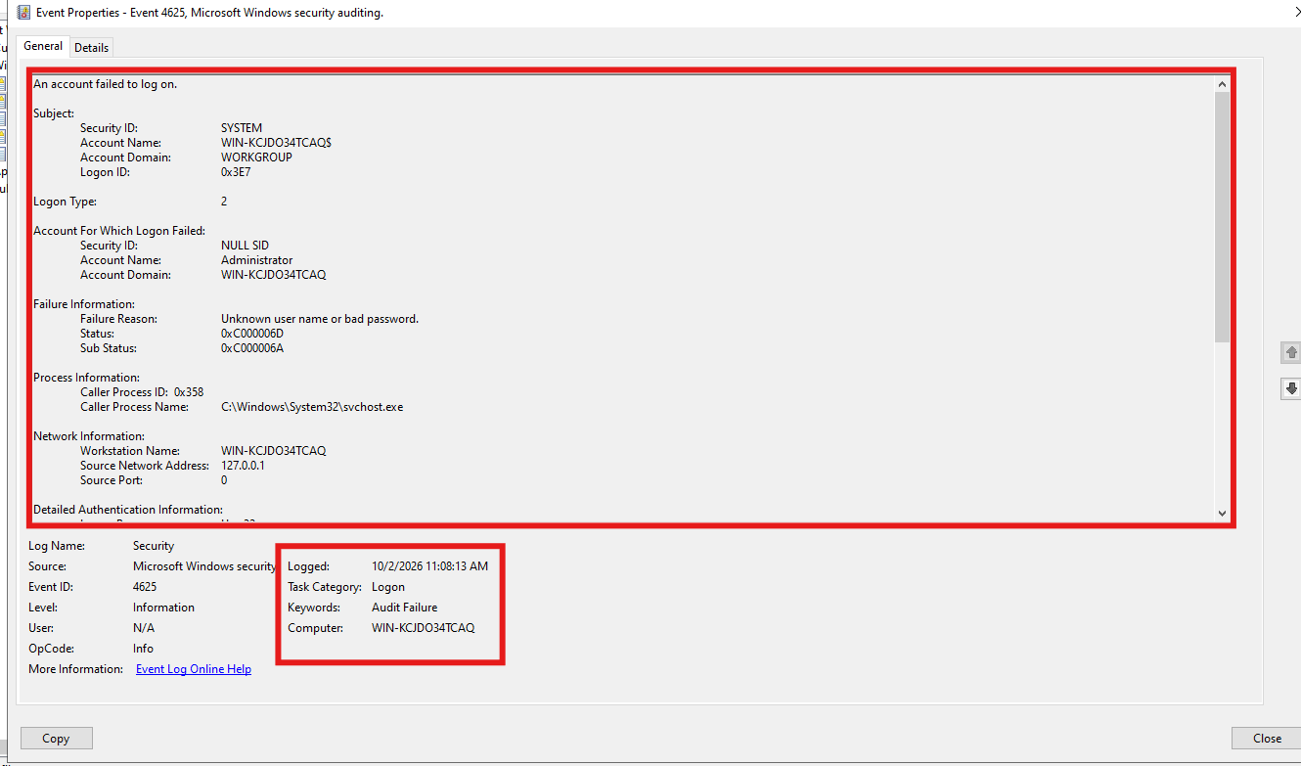
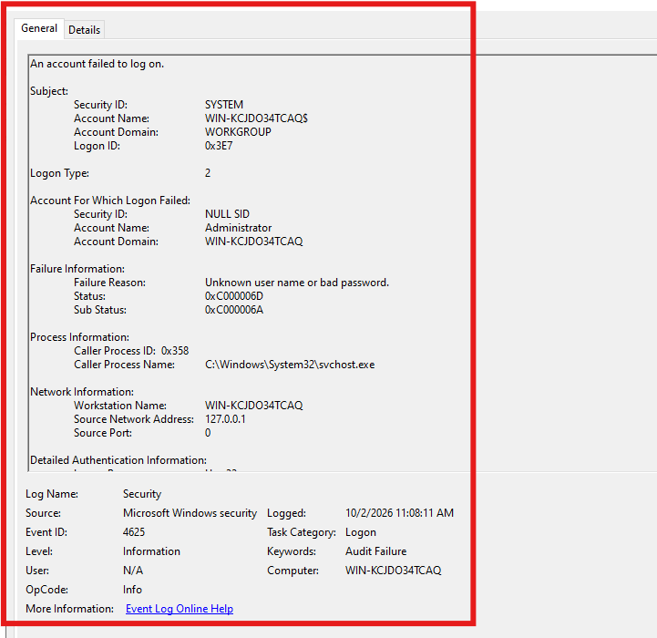
- Credential Misuse Test
Analyze:

Event ID 4648 – Logon Attempt Using Explicit Credentials

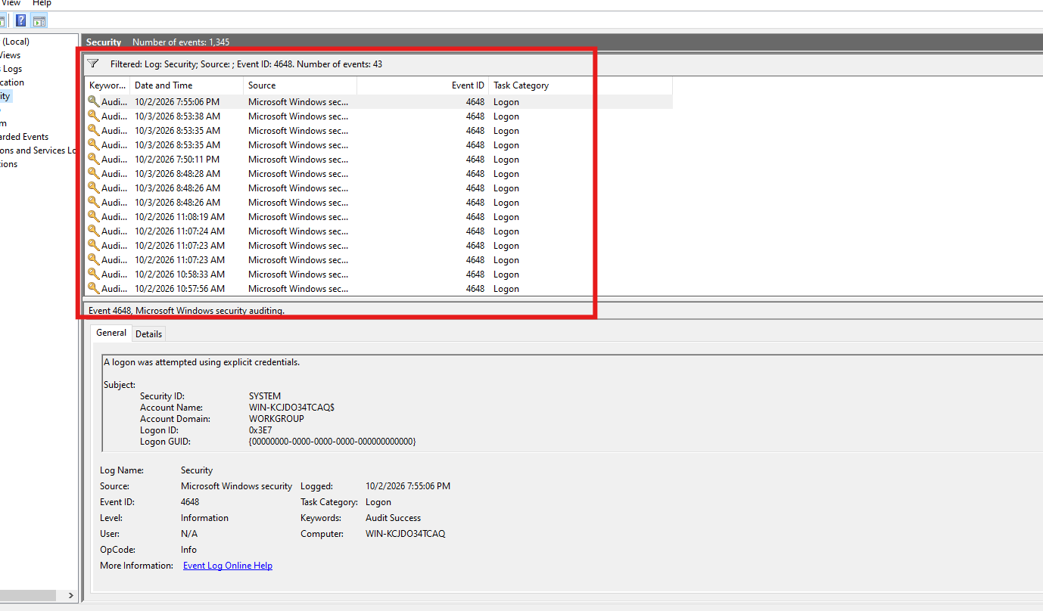
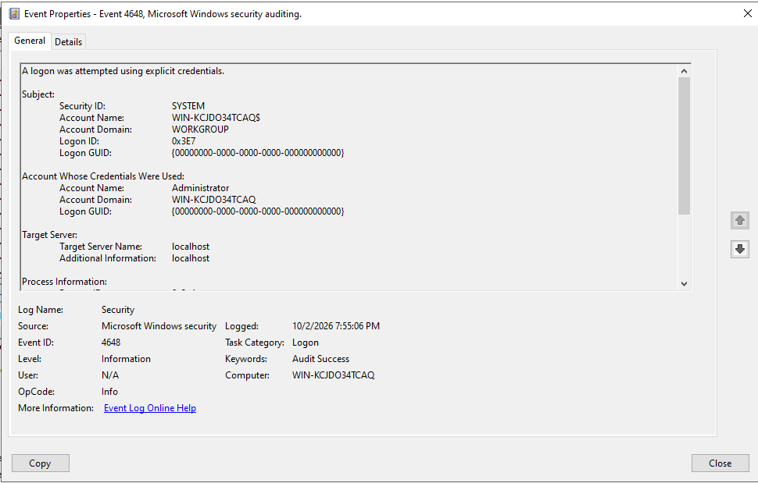

- System Shutdown Analysis
Analyze:

Event ID 1074 – System Shutdown/Restart

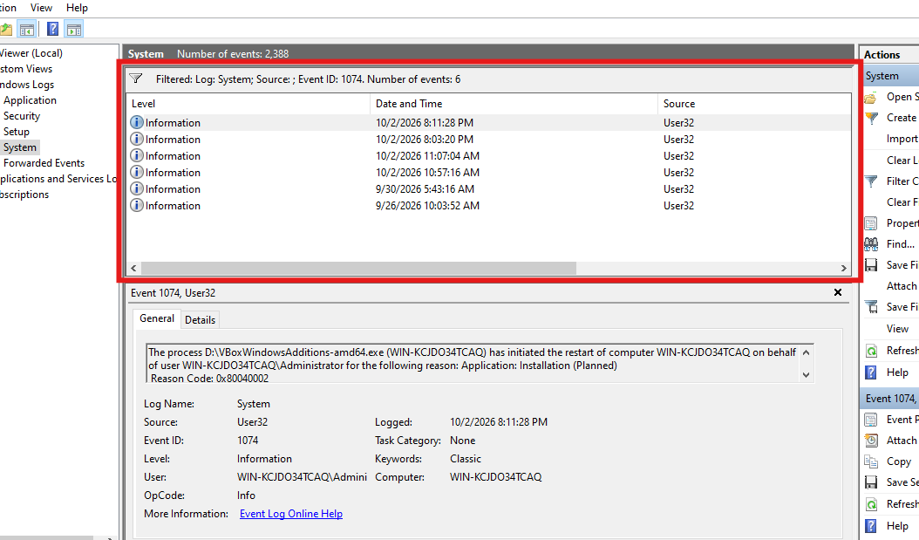
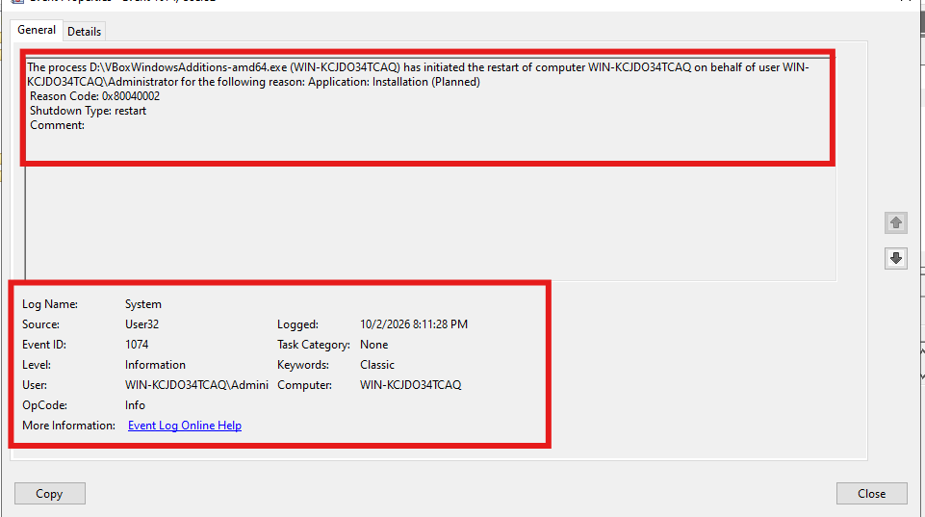

- Service Configuration Monitoring
Analyze:

Event ID 7040 – Service Startup Type Changed
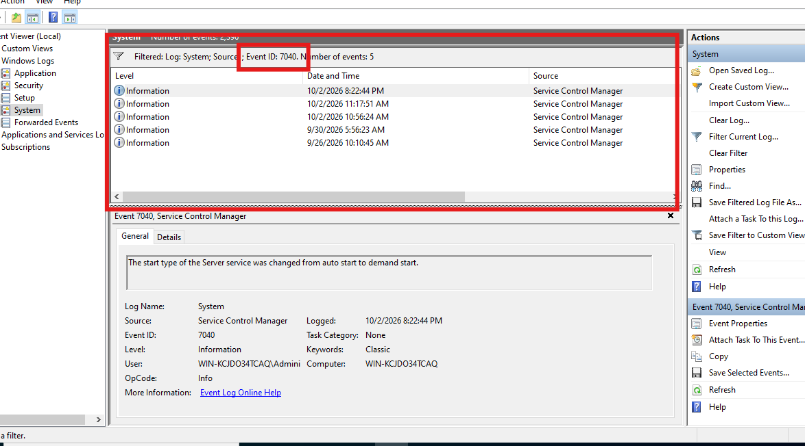
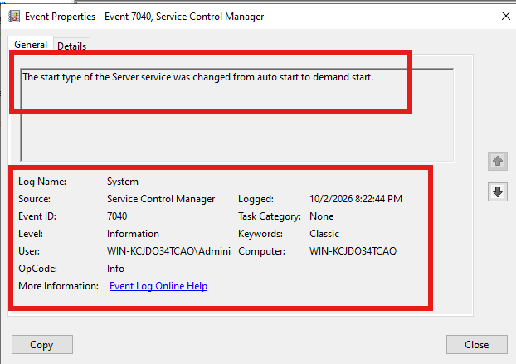

- Security Log Tampering
Analyze:

Event ID 1102 – Audit Log Cleared

Security log are available here .
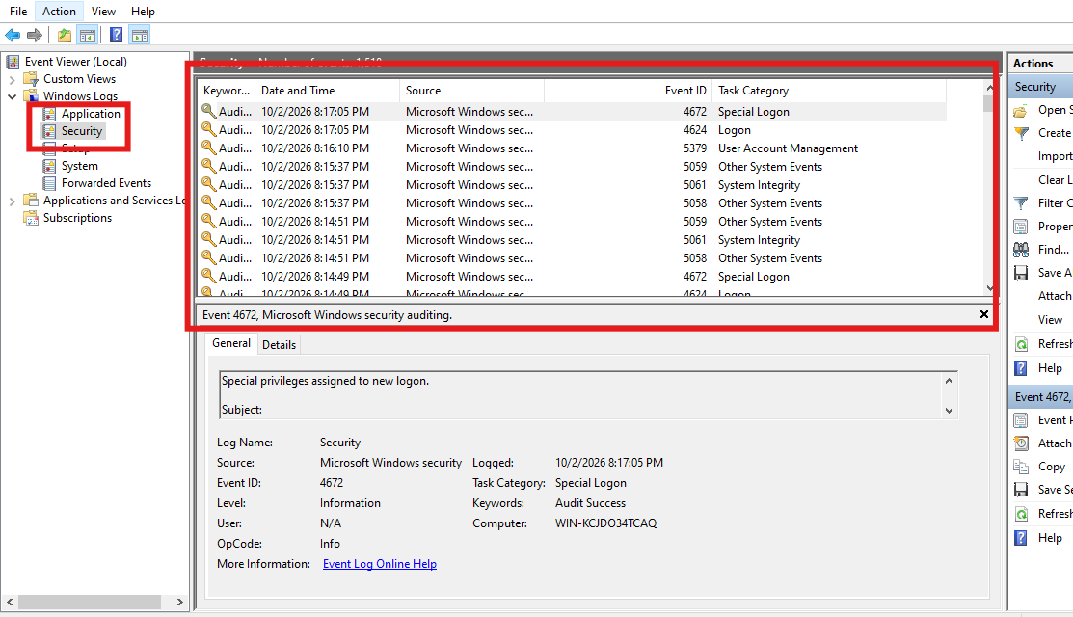

Log are cleared
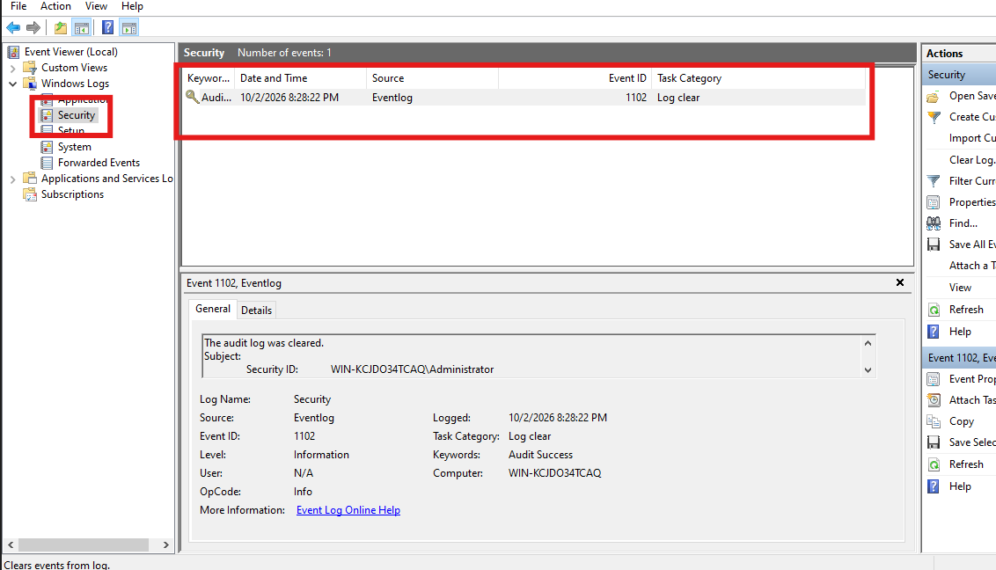
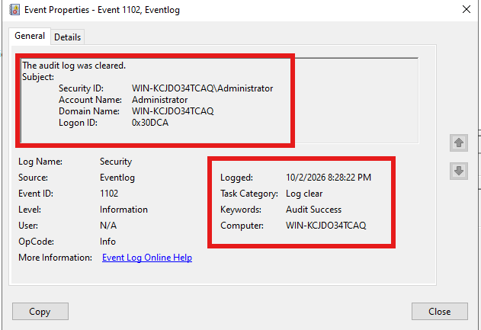

- Windows Defender Investigation
Analyze:

- Event ID 1116 – Malware Detected
- Event ID 1117 – Action Taken
- Event ID 1118 – Action Failed (if generated)
- Event ID 1006 – Malware Found

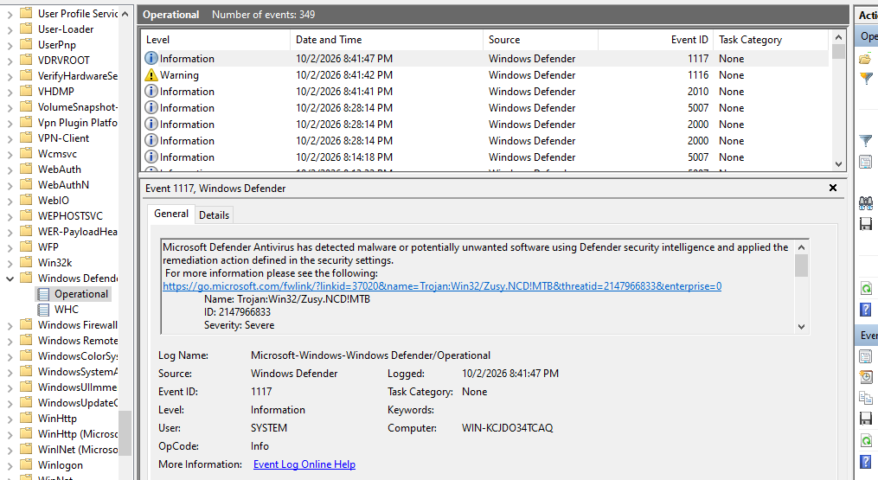

Event ID 1116 – malware detected
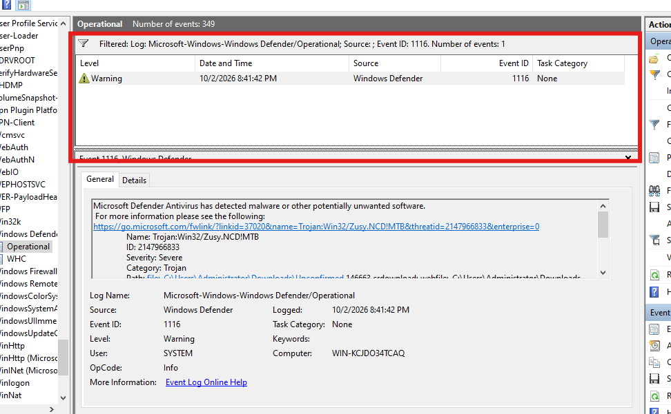
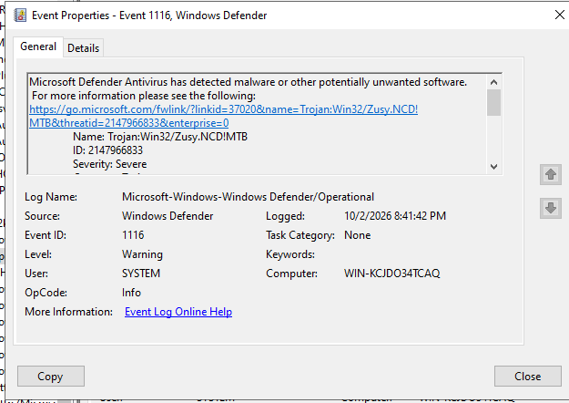

Event ID 1117 – Action Taken
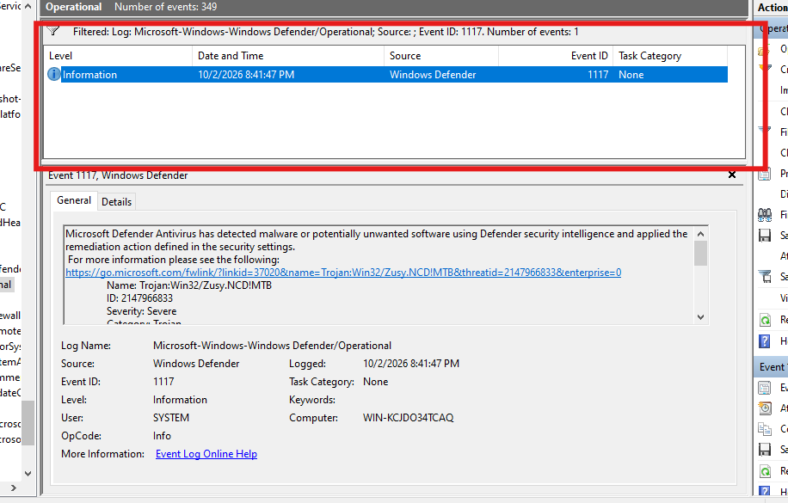
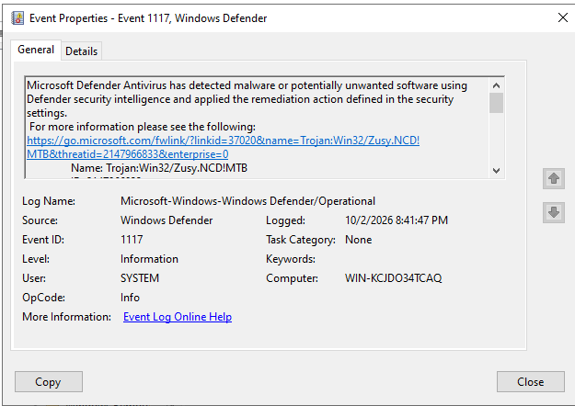

Event ID 1118 – Action Failed (if generated)
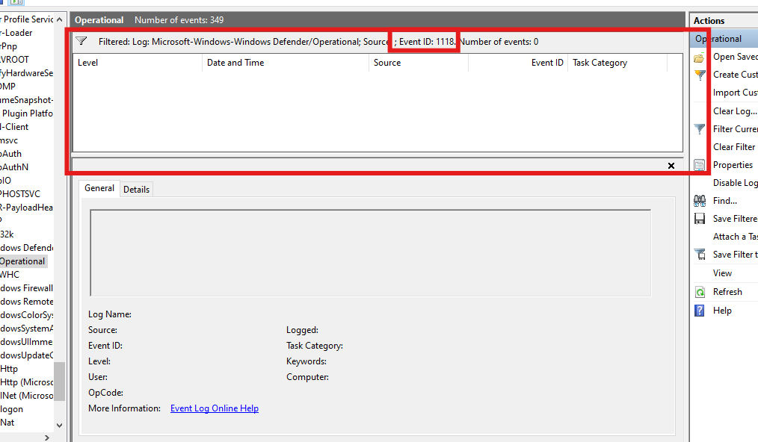

Event ID 1006 – Malware Found

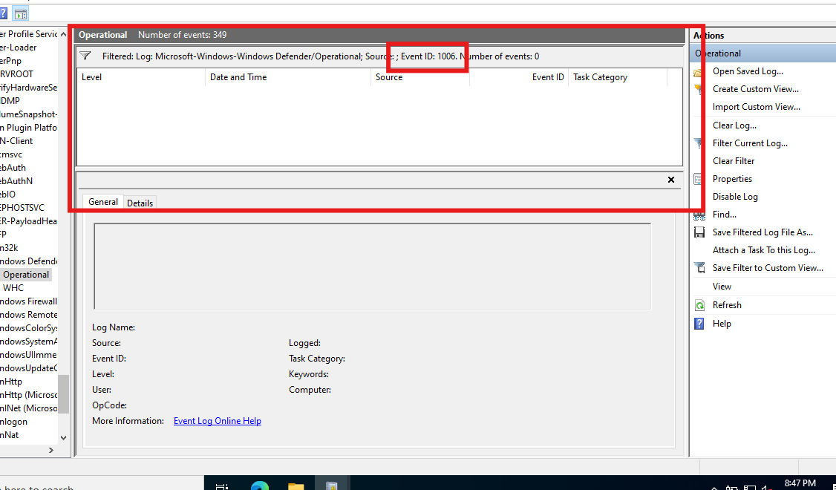
- User Account Management Investigation
Analyze:

- Event ID 4720 – User Created
- Event ID 4732 – Added to Administrators Group
- Event ID 4733 – Removed from Administrators Group
- Event ID 4726 – User Deleted

Create a new user.
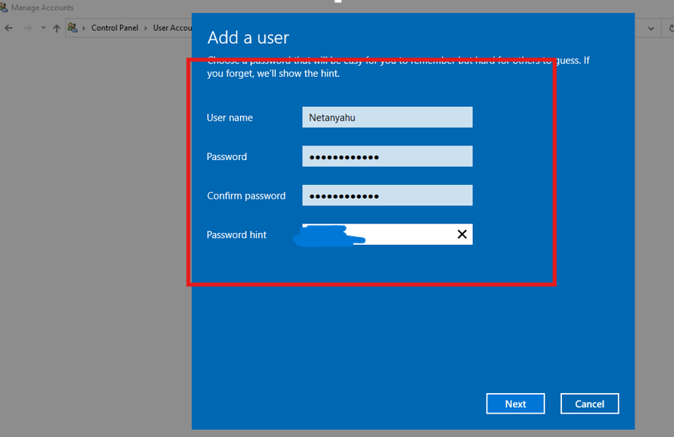

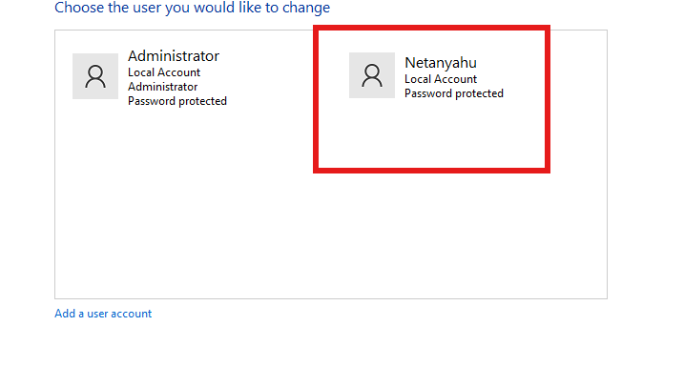
Add the user to Administrators group.
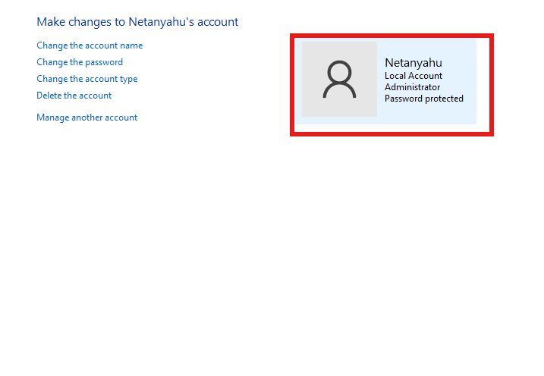

Remove the user from Administrators group
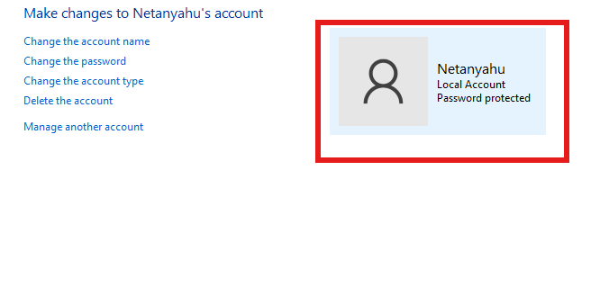
Delete the user.
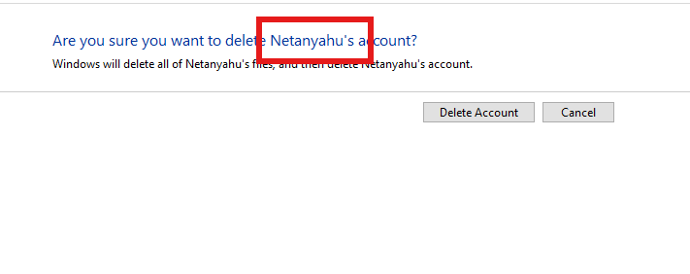

Event ID 4720 – User Created
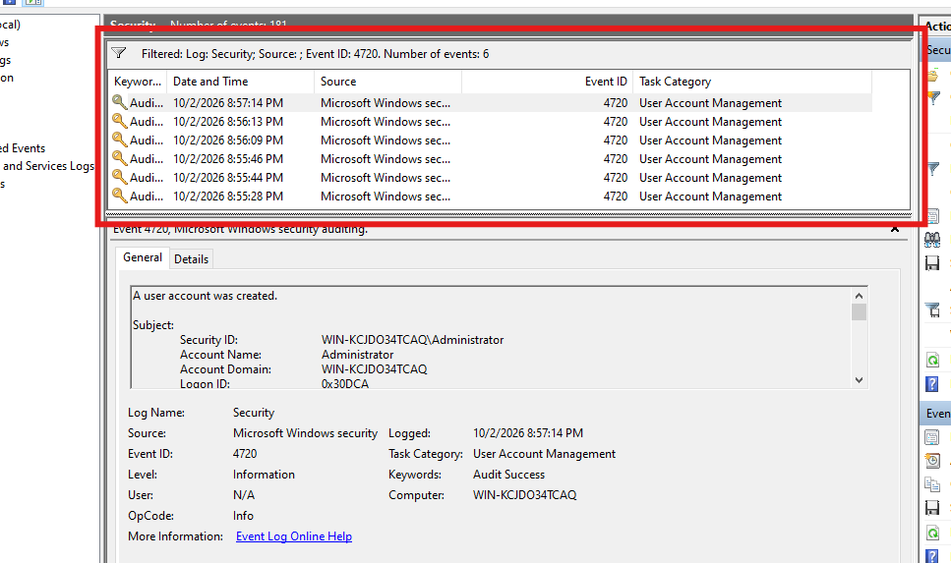
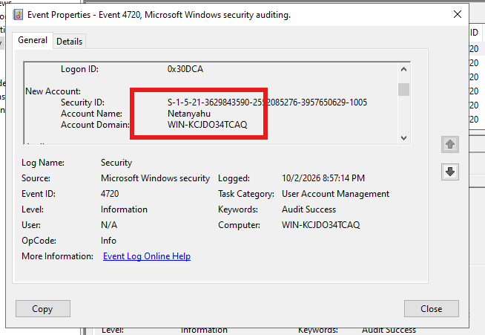

Event ID 4732 – Added to Administrators Group
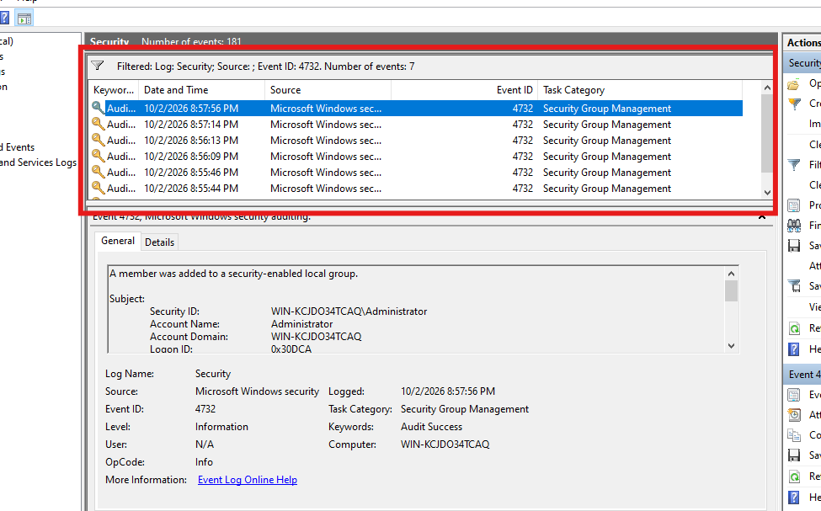
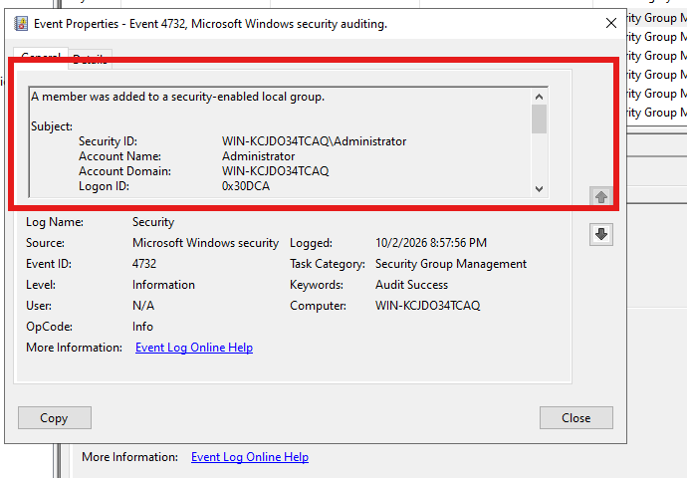
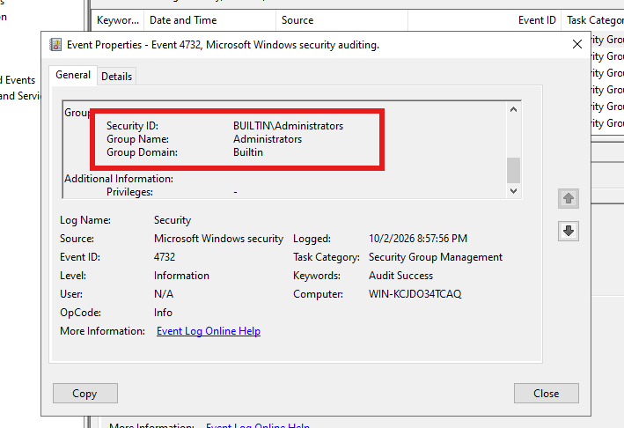

Event ID 4733 – Removed from Administrators Group
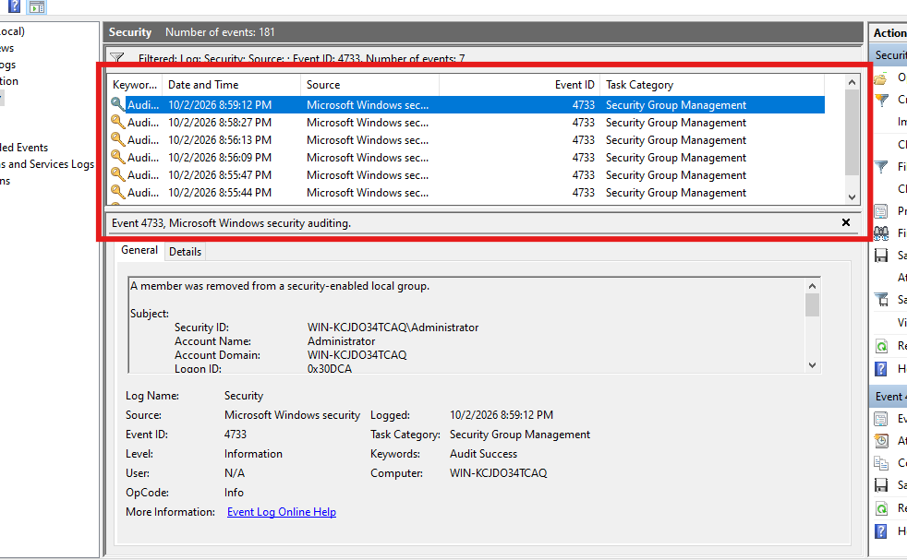
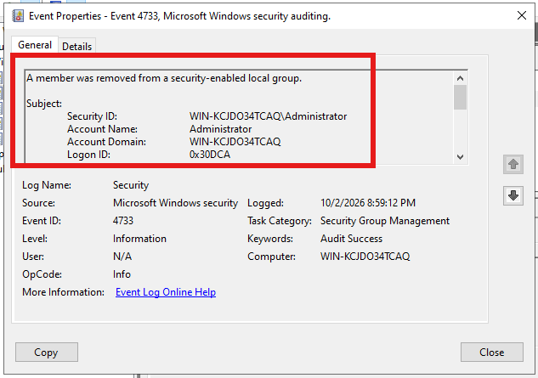

Event ID 4726 – User Deleted


